You’re Invited
Arkansas
State Elks Fall Workshop

October 9 – 11, 2020

Masquerade Banquet
Saturday, October 10
Cocktail Hour 5:30 – 6:30 Banquet 6:30
Costumes Optional but Encouraged

Host Lodge:
Mena Lodge 781
124 Elks Lane
Mena, AR 71953
479.394.3740

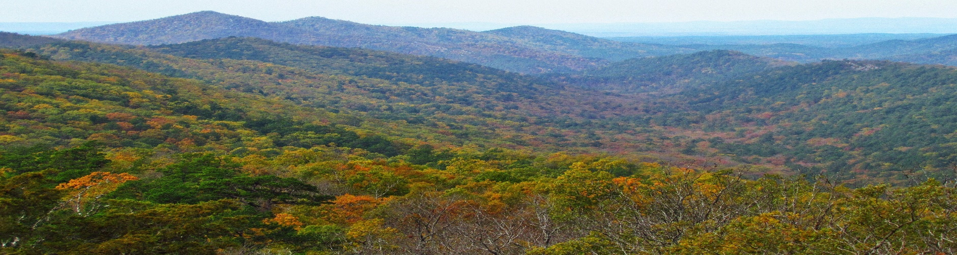

Welcome to Mena, Arkansas

LODGING
Sun Country Inn
479.394.7477
1309 N. U.S. Hwy. 71, Mena, AR
$99 + tax
Reserve by 9/9/20 and mention Elks Fall Workshop for Negotiated Rate
www.suncountryinn.com

Mena Mountain Top Cabins
479.394.1771
141 Cabins Lane, Mena, AR
Reserve by 9/9/20 and mention Elks Fall Workshop for 10% discount
Multiple cabins available. 2-4 person $125-$145 based upon included amenities (full kitchen, jacuzzi, etc.)
Cabins with up to 9 person occupancy - call for pricing.
www.menamtntopmotelcabins.com

Ozark Inn
479.394.1100
2102 Hwy. 71, Mena, AR
$55 (1 bed) - $65 (2 beds) + tax
Reserve by 9/9/20 and mention Elks Fall Workshop for Negotiated Rate
www.ozarkinnmenaar.com

Executive Inn
479.394.3710
704 U.S. Hwy. 71, Mena, AR
$45 (1 bed) - $55 (2 beds) + tax
www.executiveinnatmena.com

RV Spots $25.00 per night with water & electric
Mena Elks Lodge: 479.394.3740
Polk County Fairgrounds: 479.243.6212

For a complete listing of amenities and attractions in Mena visit www.visitmena.com

ARKANSAS STATE ELKS FALL WORKSHOP
REGISTRATION FORM

Attendee(s) Name & Title: _________________________________________________________

_________________________________________________________

Address: _______________________________________________________________________

_______________________________________________________________________________

Phone Number: _________________________ Lodge: _________________________________

Number Attending Banquet: _____ x $55 = $_________

Number Attending Saturday Ladies Brunch: __________

Saturday Banquet:
Choose one per person:
_____ Prime Rib
_____ Stuffed Chicken
_____ Keto Chicken

Please RSVP by September 15, 2020

Mail this registration form and check to:

Mena Elks Lodge
124 Elks Lane
Mena, AR 71953

